FORCES

Forces can cause the following changes to objects they act on. They can:

• cause an object to accelerate—that is, to increase its velocity.
• cause an object to decelerate—that is, to decrease its velocity.
• cause an object to change its direction.
• cause a change of shape.

In order for a force to do these things, two conditions must be met.

1. The force must be unbalanced.

In order for a force to cause a change of velocity, direction or shape there must be an
unbalanced force in the direction of the change.

If the force is balanced by another force, the forces cancel each other out because they
are acting in opposite directions.

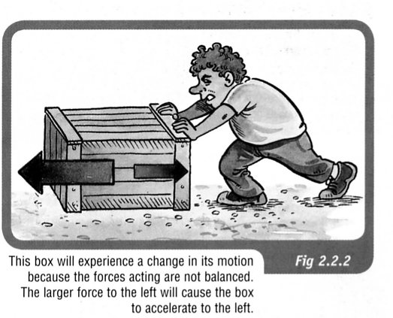

2. The force must be external.

Can you move a car by sitting inside it and pushing on the steering wheel?
Of course, the answer is no.

If you wanted to push a car, you would have to stand outside the car and
push it.

To fully understand how forces can do these things, one needs to understand Newton’s Three Laws of Motion.

NEWTON'S FIRST LAW

A body at rest or moving at constant velocity will continue
to do so unless acted upon by an external unbalanced force.

Example
The force needed to move an object appears to be dependent on the mass.
MASS
FORCE

The larger the mass, the greater the force required to move the object.

Newton's First Law is often referred to as the law of inertia.

Inertia is considered to be the property of a body which, when still, makes it hard to move and, when moving, keeps it going.

This property seems to be determined by mass - the greater the mass, the greater the inertia.

Examples

1. A train has a lot of inertia due to its large size. It takes a great deal of force to start it moving
(if it's stationary) or stop it (if it's moving).

2. Consider a passenger in a car moving at 60.0 kmh⁻¹. If the car brakes suddenly, the
passenger will continue to move forward at 60.0 kmh⁻¹ (due to inertia), until the seatbelt
exerts a force on them to slow them down.

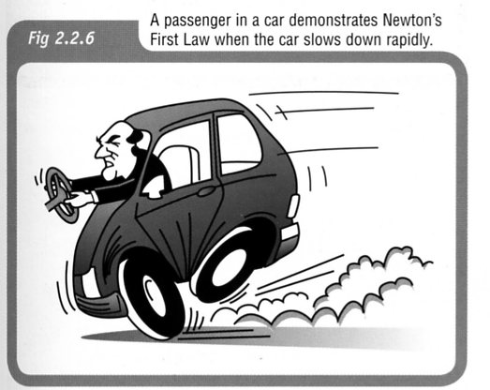

3. If a car accelerates quickly from a standing start, a passenger is thrown back in their seat.
They want to stay stationary (due to inertia) and the car moves forwards under them.

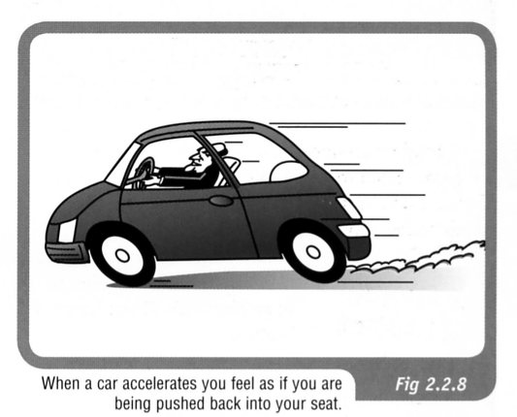

4. When a car turns a corner, the passengers have inertia that wants to keep them moving
straight ahead. The car moves under them and the passengers feel as if they are moving
(leaning) in the opposite direction to the turn.

Because of this, people assume a centrifugal force is acting on the passengers pushing them
away from the corner.

THIS IS FALSE - THE "FORCE" DOESN'T EXIST!!

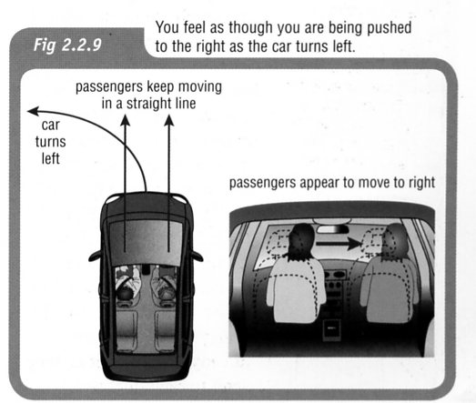

MORE ABOUT FORCES

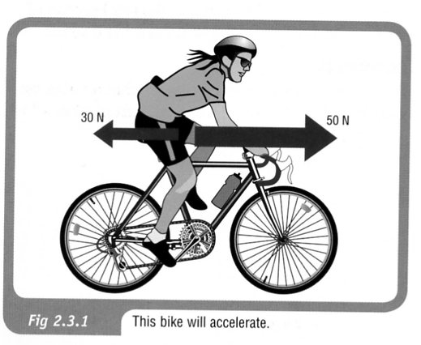
Unbalanced Forces

In the diagram at right, the bike experiences an unbalanced force of 20 newtons in a forward direction.

The bike will therefore accelerate in a forward direction because of the effect of this unbalanced forward force.

To calculate the resultant force, take forwards as positive.

=> The force backwards is negative.

∴ ΣF = 50 - 30 = 20 N forwards.

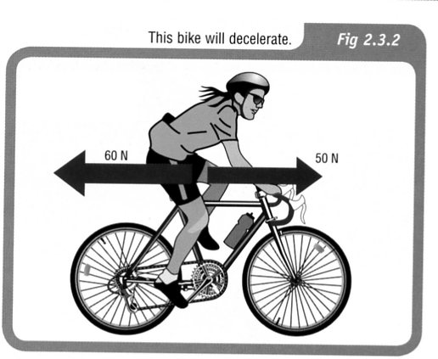

However, if the girl is not pedalling hard enough to overcome all the friction, the unbalanced force acting on the bike is 10 newtons in the opposite direction from the direction that the bike is moving.

The bike will therefore not be able to maintain a constant velocity but will decelerate.

Take forwards as positive.

ΣF = 50 - 60 = -10 N
the negative sign means the direction is backwards.

∴ ΣF = 10 N backwards.
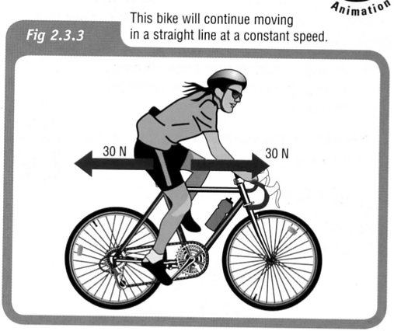

If the girl’s forward pedalling force is exactly the same
size as the frictional force in the opposite direction, there
is no unbalanced force acting on the bike.

The bike will not accelerate or decelerate but will
continue in a straight line with a constant
speed.

∴ ΣF = 0
NEWTON'S SECOND LAW

An external unbalanced force will cause an object to accelerate in the
direction of the resultant force.

This is represented by:
ΣF = ma

where ΣF = the resultant unbalanced force acting (N)
m = mass of the object (kg)
a = acceleration (ms⁻²)

Examples

1. What would be the acceleration of a skateboarder and her skateboard if their combined mass
of 55.0 kg was acted on by an accelerating force of 60.0 N?

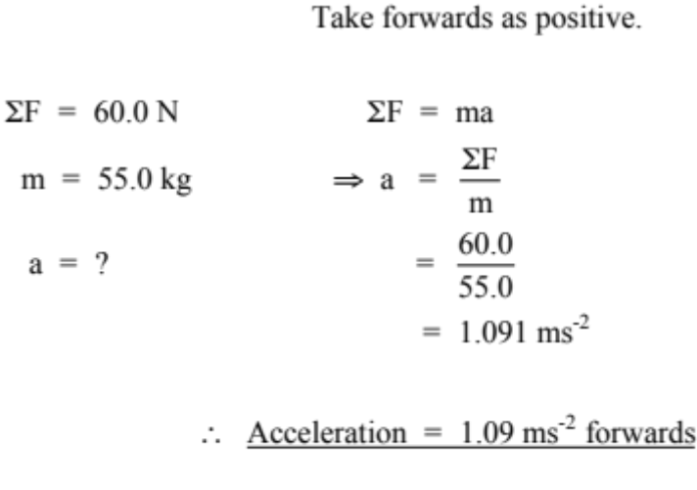
2. A car of mass 1.10 x 10³ kg is accelerated by a motor that provides a force of 3.10 x 10³ N.
A frictional force of 8.50 x 10² N opposes the motion of the car. Calculate the acceleration of
the car across the ground.
F_{friction} = 8.50 x 10² N
F_{engine} = 3.10 x 10³ N

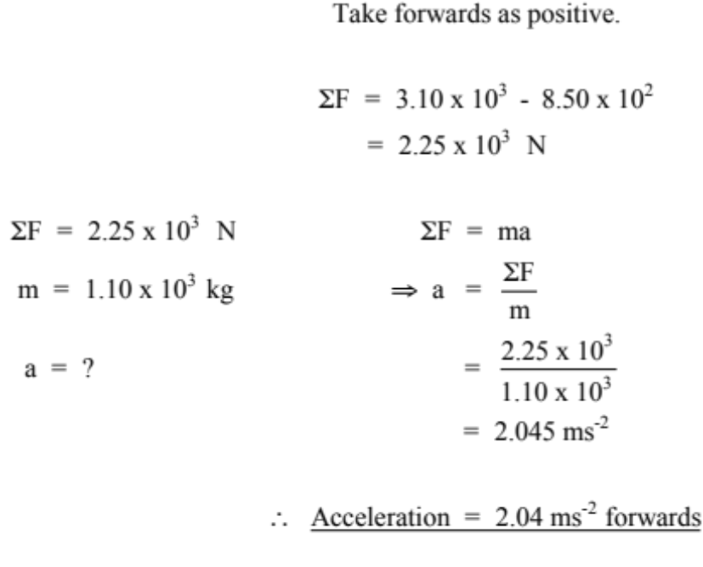

Gravity and Weight

Most objects fall back to Earth due to gravity, one of the fundamental forces in the universe.

According to Isaac Newton, gravity is due to the attraction between two masses.

i.e. There is an attraction between you and the person next to you, your pens and pencils,
the Earth, etc.

The attraction to the Earth is the strongest since its mass is so large (5.98 x 10²⁴ kg).

Two terms need to be clearly distinguished.

Mass - amount of matter in an object (measured in kg).

Weight - force due to gravity on an object (measured in Newtons - N).

The mass of an object does not change throughout the universe while the weight will constantly change as it is moved from place to place.

As seen previously, the acceleration due to gravity on the earth's surface is:

g = 9.80 ms⁻²

The force due to weight (F_{w}) is given by:

F_{w} = mg
where g = the acceleration due to gravity (ms⁻²)

Example

The gravitational field on Jupiter is 2.50 times greater than that on Earth. If it was possible for a person of 80.0 kg to stand on Jupiter's surface, calculate their weight.

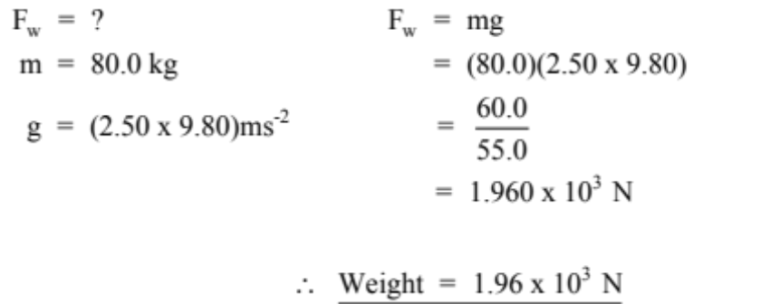
NEWTON'S THIRD LAW

For every action there is an equal and opposite reaction.

Newton realised that forces occur in pairs and act on different objects.

e.g. Consider a block sitting at rest on a table.

The force due to gravity (weight) acts downwards on the block. Thus the block exerts a force onto the table.

The table exerts an equal and opposite force to support it. The table exerts a force onto the block.

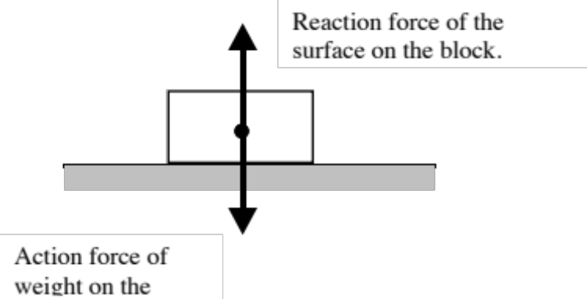
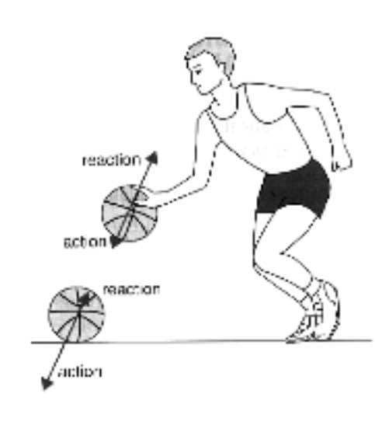

Examples

1. The player pushes on the ball (action) and the ball pushes back equally on his hand (reaction).

When the ball hits the ground, the ball pushes on the ground (action) while the ground pushes back equally (reaction).

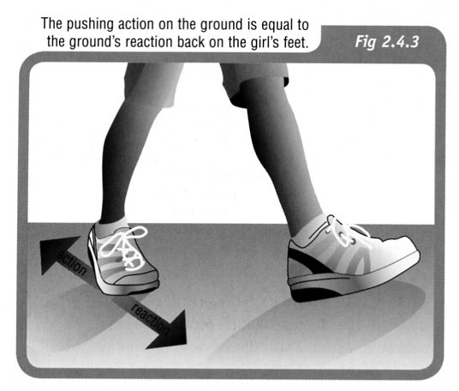

2. The girl is able to walk because friction allows
her to push backwards on the ground.

The ground in turn pushes back on her feet, by
the same force but in the opposite direction.

3. The diagram shows the reaction chamber for a
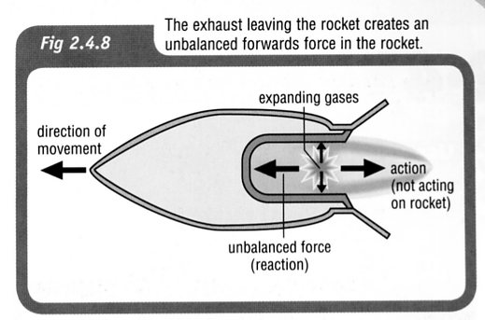
rocket.

As the fuel burns, the expanding gases push in
all directions.

The gases rush out the exhaust outlet (action),
causing a push on the rocket (reaction) that
moves it forwards.

This unbalanced force is called thrust.

